God and saying, ¹⁴ “Glory to God in the highest heaven, and on earth peace to those on whom his favor rests.” ¹⁵ When the angels had left them and gone into heaven, the shepherds said to one another, “Let’s go to Bethlehem and see this thing that has happened, which the Lord has told us about.” ¹⁶ So they hurried off and found Mary and Joseph, and the baby, who was lying in the manger. ¹⁷ When they had seen him, they spread the word concerning what had been told them about this child, ¹⁸ and all who heard it were amazed at what the shepherds said to them. ¹⁹ But Mary treasured up all these things and pondered them in her heart. ²⁰ The shepherds returned, glorifying and praising God for all the things they had heard and seen, which were just as they had been told. ²¹ On the eighth day, when it was time to circumcise the child, he was named Jesus, the name the angel had given him before he was conceived.  Songs of Christmas: Angels  Reverend Janet Russell  Hark! The Herald Angels Sing  Silent Night Holy Night  Benediction  Angels We Have Heard on High  Fellowship Calendar:  December 24, Sunday – After Service, join us in McHattie Hall to sing carols and eat pie!  Coffee & Donuts:  December 24 – Bring pies to share! 😊  December 31 – Norm Pratt  Welcome  Call to Worship – Hardy Hemphill  Isaiah 9:2, 6-7  Leader: The people walking in darkness have seen a great light; on those living in the shadow of death a light has dawned.  People: For to us a child is born, to us a son is given, and the government will be on His shoulders.  Leader: And he will be called Wonderful Counselor, Mighty God, Everlasting Father, Prince of Peace.  People: Of the increase of his government and peace there will be no end.  Leader: He will reign on David's throne and over his kingdom, establishing and upholding it with justice and righteousness from that time on and forever.  People: The zeal of the Lord Almighty will accomplish this.  Lighting the Advent Wreath – Judy & Rhiannon McDowell  Reader 1: We light all four candles, plus also the Christ candle, as a sign that the people who walked in darkness have seen a great light; those who lived in a land of deep darkness, on them light has shined.  Reader 2: The angels said, “Glory to God in the highest heaven, and on earth peace to those on whom his favor rests.”  All: God of grace, ever faithful to your promises, may your glory fill the heavens and the earth, and your peace rest upon us all. We look forward with longing to Jesus’ return at the end of time. Prepare our hearts to receive him when he comes, for he is Lord forever and ever. Amen. |  | Sunday Service  December 24, 2023  11 am  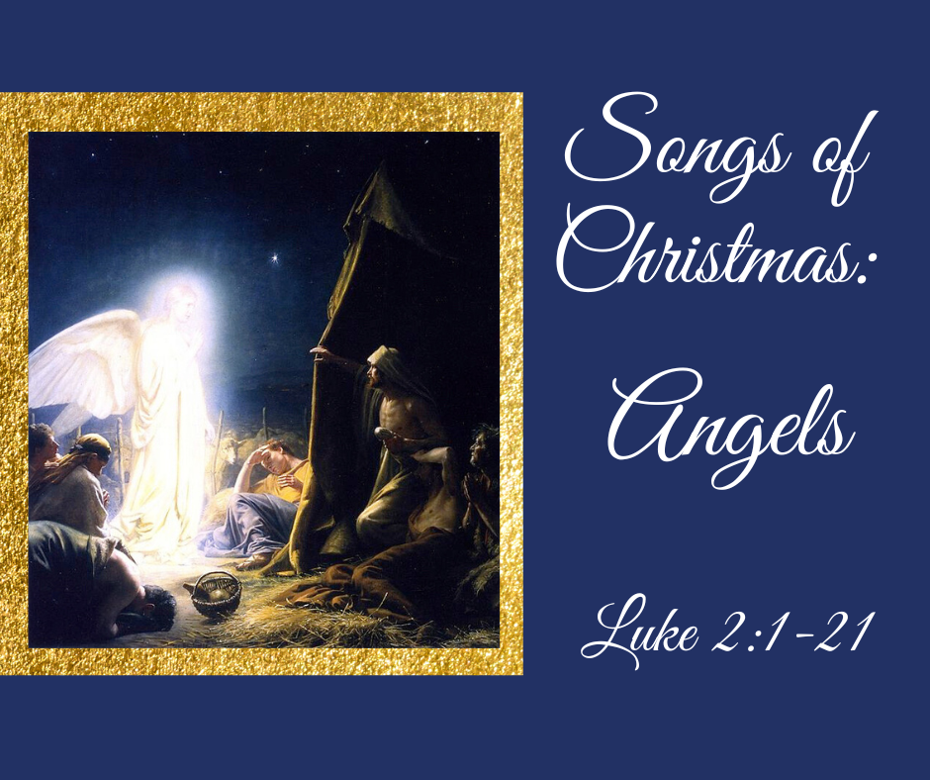  West Valley Presbyterian Church  6191 Bollinger Road, Cupertino CA 95014  wvpc.org  Angels from the Realms of Glory  Joy to the World  O Come, All Ye Faithful  What Child Is This  Greetings & Announcements – Rev. Janet Russell  Prayers of the People – Donna Perry  Our Father, who art in heaven, hallowed be thy name, thy kingdom come, thy will be done, on earth as it is in heaven. Give us this day our daily bread; and forgive us our debts, as we forgive our debtors; and lead us not into temptation but deliver us from evil. For thine is the kingdom, and the power, and the glory, forever. Amen.  Luke 2:1-7 – Rev. Bob Harrison  2 In those days Caesar Augustus issued a decree that a census should be taken of the entire Roman world. ² (This was the first census that took place while^{[a]} Quirinius was governor of Syria.) ³ And everyone went to their own town to register. ⁴ So Joseph also went up from the town of Nazareth in Galilee to Judea, to Bethlehem the town of David, because he belonged to the house and line of David. ⁵ He went there to register with Mary, who was pledged to be married to him and was expecting a child. ⁶ While they were there, the time came for the baby to be born, ⁷ and she gave birth to her firstborn, a son. She wrapped him in cloths and placed him in a manger, because there was no guest room available for them.  O Little Town of Bethlehem  Breath of Heaven  Luke 2:8-21 NIV  ⁸ And there were shepherds living out in the fields nearby, keeping watch over their flocks at night. ⁹ An angel of the Lord appeared to them, and the glory of the Lord shone around them, and they were terrified. ¹⁰ But the angel said to them, “Do not be afraid. I bring you good news that will cause great joy for all the people. ¹¹ Today in the town of David a Savior has been born to you; he is the Messiah, the Lord. ¹² This will be a sign to you: You will find a baby wrapped in cloths and lying in a manger.” ¹³ Suddenly a great company of the heavenly host appeared with the angel, praising

