Slides for 8/21 Peter the Presbyter
Slide 1
“Now as an elder myself and a witness of the sufferings of Christ, as well as one who shares in the glory to be revealed, I exhort the elders among you to tend the flock of God that is in your charge”…….(vv1 and 2a)

Slide 2
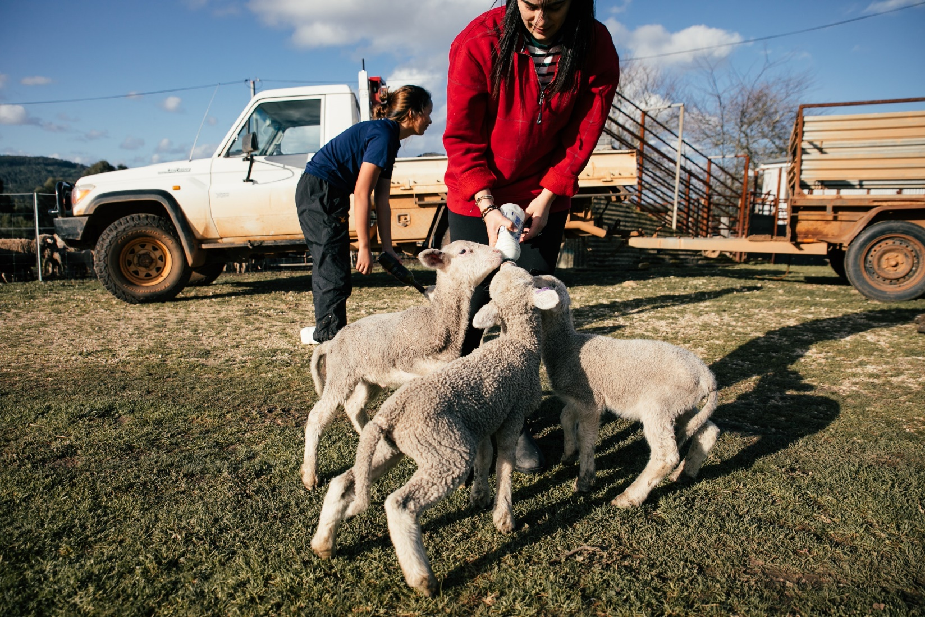

Slide 3
“exercising the oversight, not under compulsion but willingly, as God would have you do it – not for sordid gain but eagerly.”

Slide 4

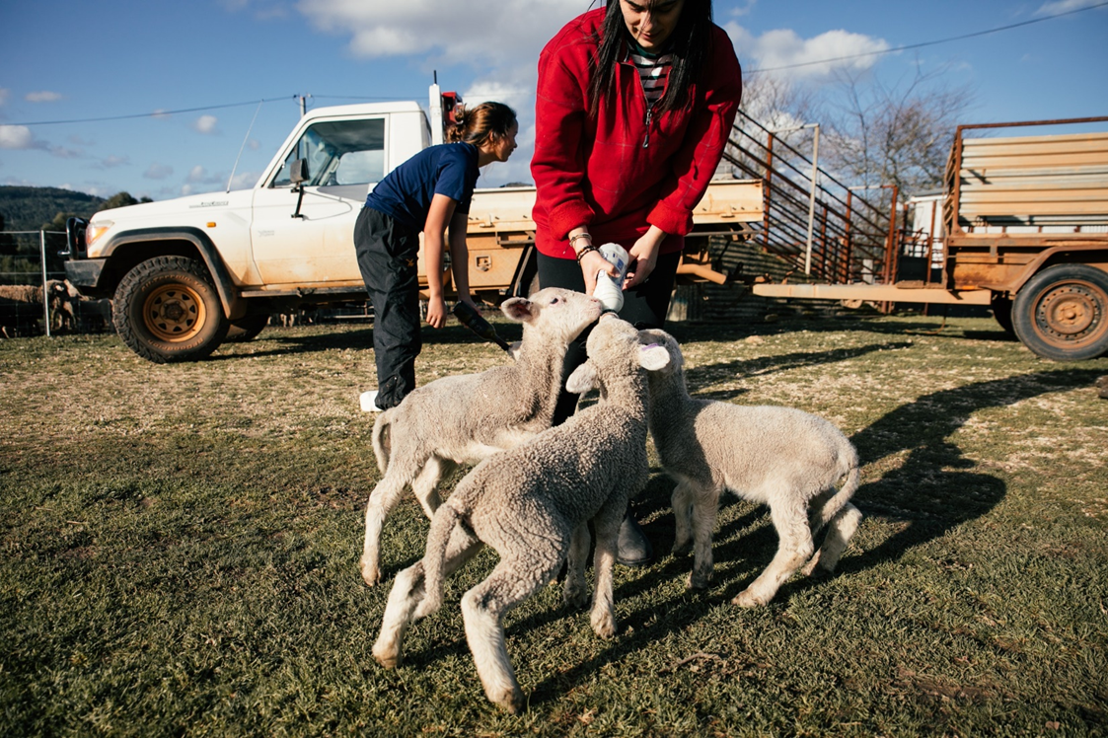

Slide 5
“Do not lord it over those in your charge, but be examples to the flock.”

Slide 6
“In the same way, you who are younger must accept the authority of the elders. And all of you must clothe yourselves with humility in your dealings with one another, for ‘God opposes the proud, but gives grace to the humble.’ Humble yourselves therefore under the mighty hand of God, so that he may exalt you in due time.”

Slide 7
“Cast all your anxieties on him, because he cares for you.”

Slide 8
“Discipline yourselves, keep alert. Like a roaring lion your adversary the devil prowls around, looking for someone to devour.”
Slide 9

Slide 10

Slide 11
“And all of you must clothe yourselves with humility in your dealings with one another…..”

